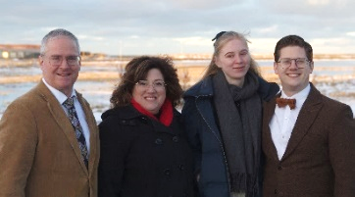
What did we do
January, 2025?

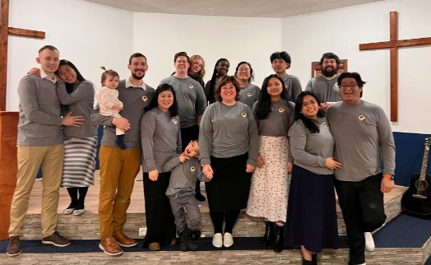
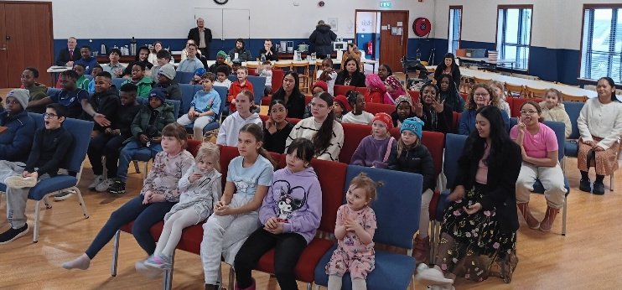
Ministry outreach: The Icelandic-speaking ministry to the community has grown each week this year with visitors every week save one. It is a joy to minister God’s Word through this open door. We are thankful for the four Sunday school groups and their teachers who minister to these precious souls. The adult attendance has also grown. We rejoice that we will baptize an adult lady, Iceland national, who professed faith in Christ next Sunday. Another adult lady wishes to be baptized at Easter this year. The adults meet with me from 2:15 to 3:15. I also have the joy of teaching the sixth-grade and older kids after ministering to the adults. Vicki, William, and Phyllis also teach each week. We minister alongside a wonderful group of volunteers from our English ministry. Thank you for praying for the workers and those with whom we minister each week. The Sears family purchased a nine-passenger van and is helping transport souls back and forth from church. This has resulted in growth as the kids don’t have to wait as long for a ride home. We are thankful for their help in this area.
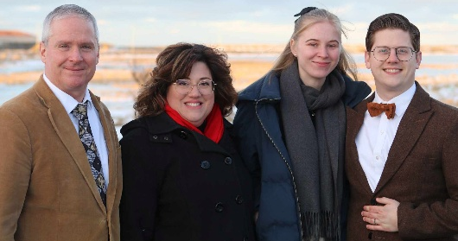
William and Phyllis raising support: We attached a letter explaining how the Weimers 2.0, William and Phyllis, are missionaries serving alongside us on the field. It is a blessing to have help right now in the work. It would be wonderful if they didn’t have to leave the field and their ministries to raise support. Many churches have seen and read about my son’s faithful service alongside us since he was a young teenager. From a child, he has ministered. Please pray for them as they seek churches to support them without requiring them to leave the field. Thank you also for praying for them as they schedule meetings from August to October. Phyllis is a German citizen. Legal immigration to the USA and applications for Green Cards is a long and tedious process. They are only able to schedule three months of meetings and then must leave. We need their help and pray that our churches will take on our partner in ministry.
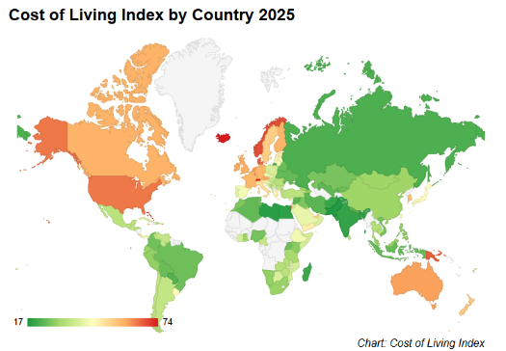
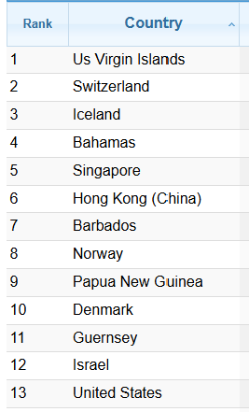
Support: Thank you for your faithful support. As shown on https://www.numbeo.com/cost-of-living/rankings_by_country.jsp, Iceland is the third most expensive place on the planet to minister. We thank God for our faithful supporters who sacrifice to keep us on the field. Filling our 18-gallon tank on the church bus costs $160 each week. That is over $8,000 per year to keep the bus rolling. Thank you so much for your giving to the Lord.

