
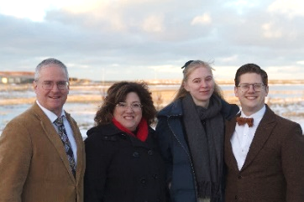
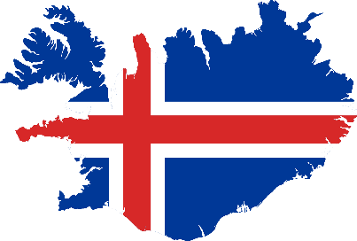

Our son William and his wife Phyllis are here in Iceland, serving on the field, but they need support. We have encouraged them to reach out to you.
William has spent his life in Iceland. He faithfully served in our ministry while studying for both a Bachelor's in Christian Education and a Bachelor's in Church Ministries from Veritas Baptist College. He then spent a year interning in the States to complete his degrees. William started a teen church here last year that is growing each month and works full-time in all aspects of ministry. His leaving for any period will have a negative impact on this work. William is a workman worthy of his hire.
Phyllis moved on her own to Iceland from Germany as a teenager, attended our church plant, and trusted Christ. She will finish her Bachelor's in Icelandic Language at the University of Iceland in May 2025. Phyllis is waiting for her paperwork from the U.S. Department of Immigration to be in the States so she can travel with William. Apparently, immigration wheels turn slowly.
William and Phyllis were married here at our church in June 2024 and became missionaries with Baptist Missions to Forgotten Peoples shortly after. Typically, missionaries spend years on deputation and then move to that field to serve. William and Phyllis are already here serving.
The church is planted and starting to grow, but we need a good translation of the Bible. As William can take on more pastoral responsibilities, Patrick can concentrate more on the translation work.
Their website is Weimers in Iceland – "…the isles shall wait for his law." – Isaiah 42:4
Feel free to contact the pastors with whom William worked during his internships:

Pastor Daniel Hawtree
Kerwin Baptist Church
Kernersville, NC
Pastor Ricky Draper
Providence Baptist Church,
Bushnell, FL

Thank you for your faithfulness over the years and for considering supporting William and Phyllis.
Patrick and Vicki Weimer, Iceland

